2D, Incompressible Stagnation Point Flow

Modal Stability Tests

# Description of result filenames

Names are in the form of “<CASE_HEADER>_<CASE_INFO>”.

Wherever “<>” is present, it should be replaced with user-defined information about the computation.

CASE_INFO describes the properties of various parameters given for the calculation, such as domain size and resolution, boundary conditions along each boundary of the domain, etc. Since CASE_INFO can be quite large, a proper separation between different properties (and types of properties) is done by a separator character, chosen as “_” for personal convenience reasons of the author.

CASE_INFO has the following properties:

|  |  |  |
| --- | --- | --- |
| **Property** | | **Description** |
| X<> | | Represents the value of domain side-limits in the chordwise direction, i.e., xlim. |
| Y<> | | Represents the value of “infinity” normal to the wall, i.e., ylim. |
| NX<> | | Represents the number of points along the chordwise direction. |
| NY<> | | Represents the number of points along the wall-normal direction. |
| BCW<> | BCWPC | Pressure compatibility condition on the wall. |
| BCWLPPE | Linearized pressure Poisson equation condition on the wall. |
| BCFF<> | BCFFDECAY | Decay of all disturbance components to zero at the far-field. |
| BCFFLPPE | Linearized pressure Poisson equation condition at the far-field, along with decay of velocity disturbance components to zero. |
| BCS<> | BCSLXDER | Linear extrapolation based on , for all disturbance components. |
| BCSLXFD | Linear extrapolation based on finite-difference type extrapolation (forward differences at x = -xlim, and backward differences at x = +xlim), for all disturbance components, i.e., . |

# Tests description

In the following, a table contains the settings for each computation that has been conducted for testing. Tables are grouped based on the reason for the test.

## Far-field position sensitivity

|  |  |  |
| --- | --- | --- |
| **Parameter** | | **Value** |
| xlim | | 20 |
| ylim | | [10 , 15 , 20 , 25] |
| Nx | | 50 |
| Ny | | 40 |
| Domain | Wall | LPPE |
| Far-field |  |
| Sides |  |

Note: cannot set ylim above 25, since it causes problems for Matlab’s ode45 to remain within the defined tolerances.

## Domain aspect ratio sensitivity

|  |  |  |
| --- | --- | --- |
| **Parameter** | | **Value** |
| xlim | | [20 , 30 , 40 , 50 , 60] |
| ylim | | 25 |
| Nx | | 50 |
| Ny | | 40 |
| Domain | Wall | LPPE |
| Far-field |  |
| Sides |  |

## Domain resolution sensitivity

|  |  |  |
| --- | --- | --- |
| **Parameter** | | **Value** |
| xlim | | 40 |
| ylim | | 25 |
| Nx | | [20 , 30 , 40 , 50] |
| Ny | | [20 , 30 , 40 , 40] |
| Domain | Wall | LPPE |
| Far-field |  |
| Sides |  |

## Wall boundary conditions effect

|  |  |  |
| --- | --- | --- |
| **Parameter** | | **Value** |
| xlim | | 40 |
| ylim | | 25 |
| Nx | | 50 |
| Ny | | 40 |
| Domain | Wall | [, or LPPE] |
| Far-field |  |
| Sides |  |

## Far-field boundary conditions effect

|  |  |  |
| --- | --- | --- |
| **Parameter** | | **Value** |
| xlim | | 40 |
| ylim | | 25 |
| Nx | | 50 |
| Ny | | 40 |
| Domain | Wall | LPPE |
| Far-field | [ or LPPE] |
| Sides |  |

## Sides’ boundary conditions effect

|  |  |  |
| --- | --- | --- |
| **Parameter** | | **Value** |
| xlim | | 40 |
| ylim | | 25 |
| Nx | | 50 |
| Ny | | 40 |
| Domain | Wall | LPPE |
| Far-field |  |
| Sides | [  Or  ] |

# Results

All results were exported for the first identified eigenvalue.

## Far-field position sensitivity

### Y = 10

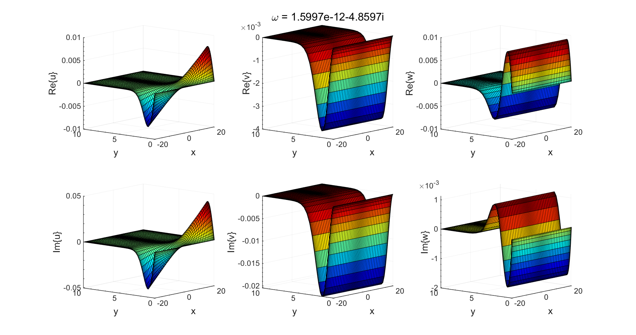

### Y = 15

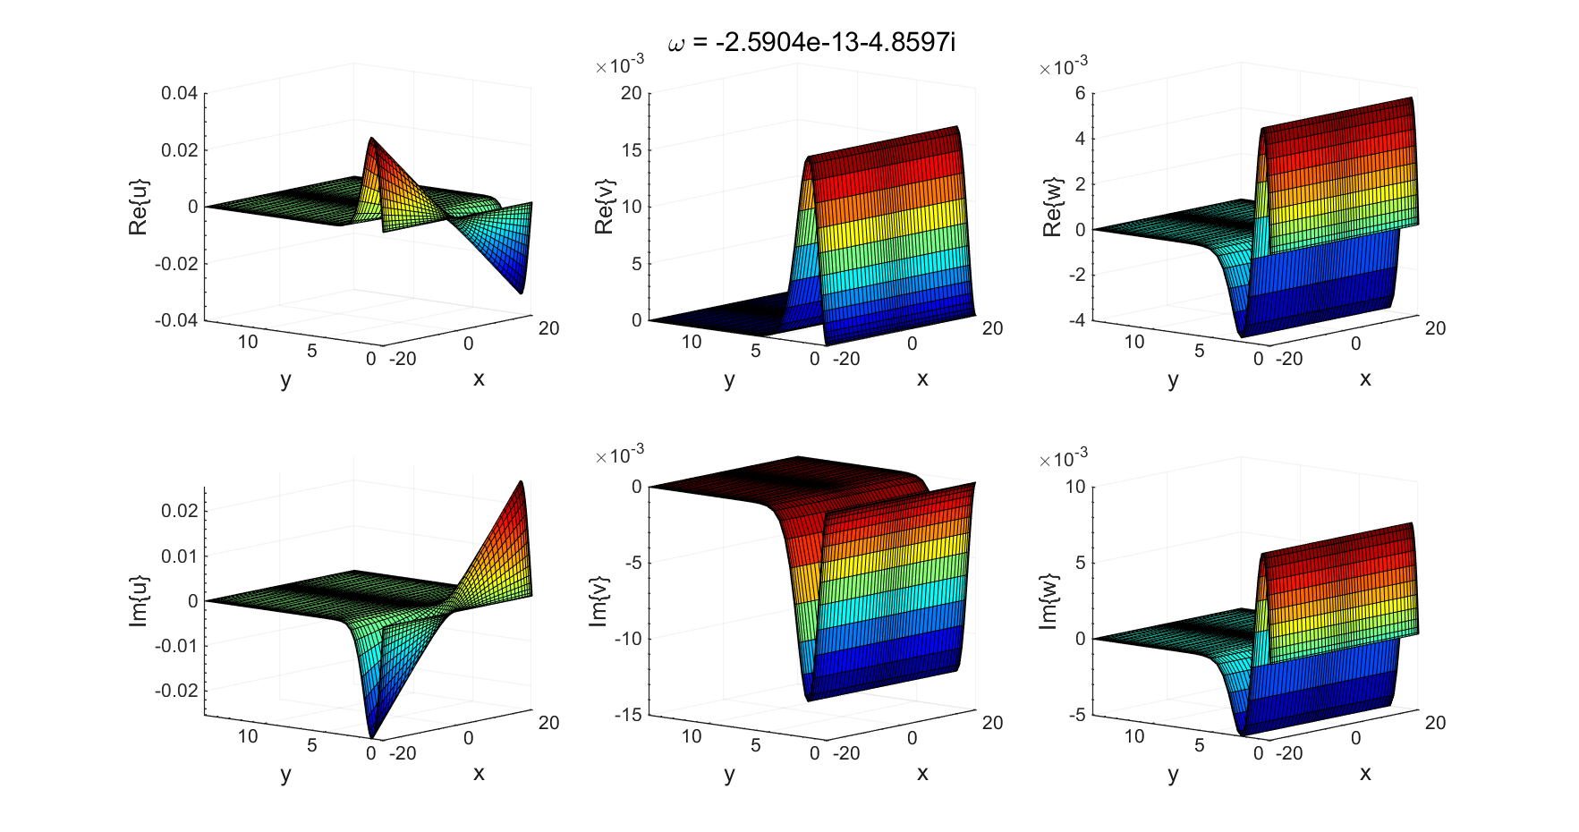

### Y = 20

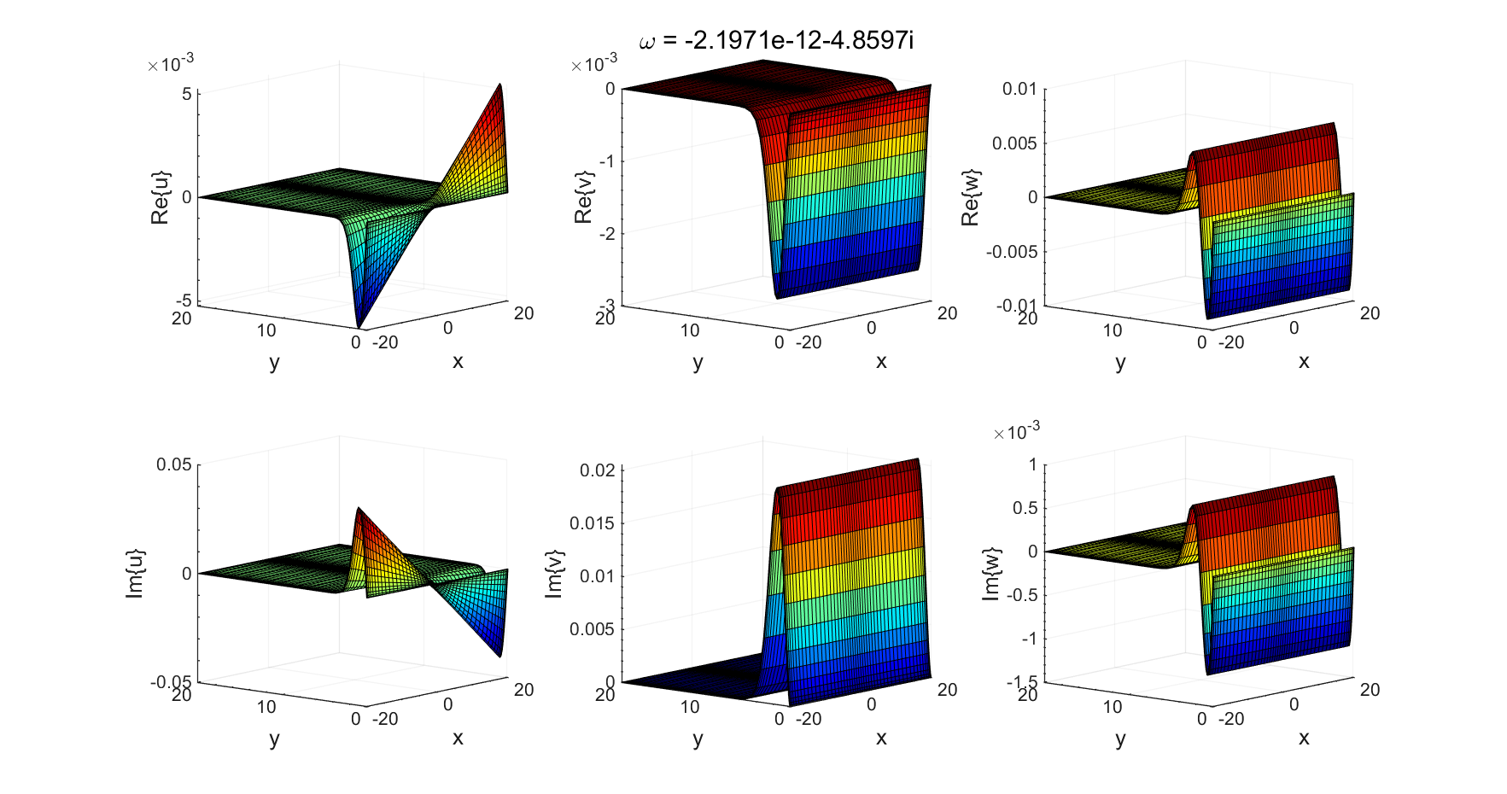

### Y = 25

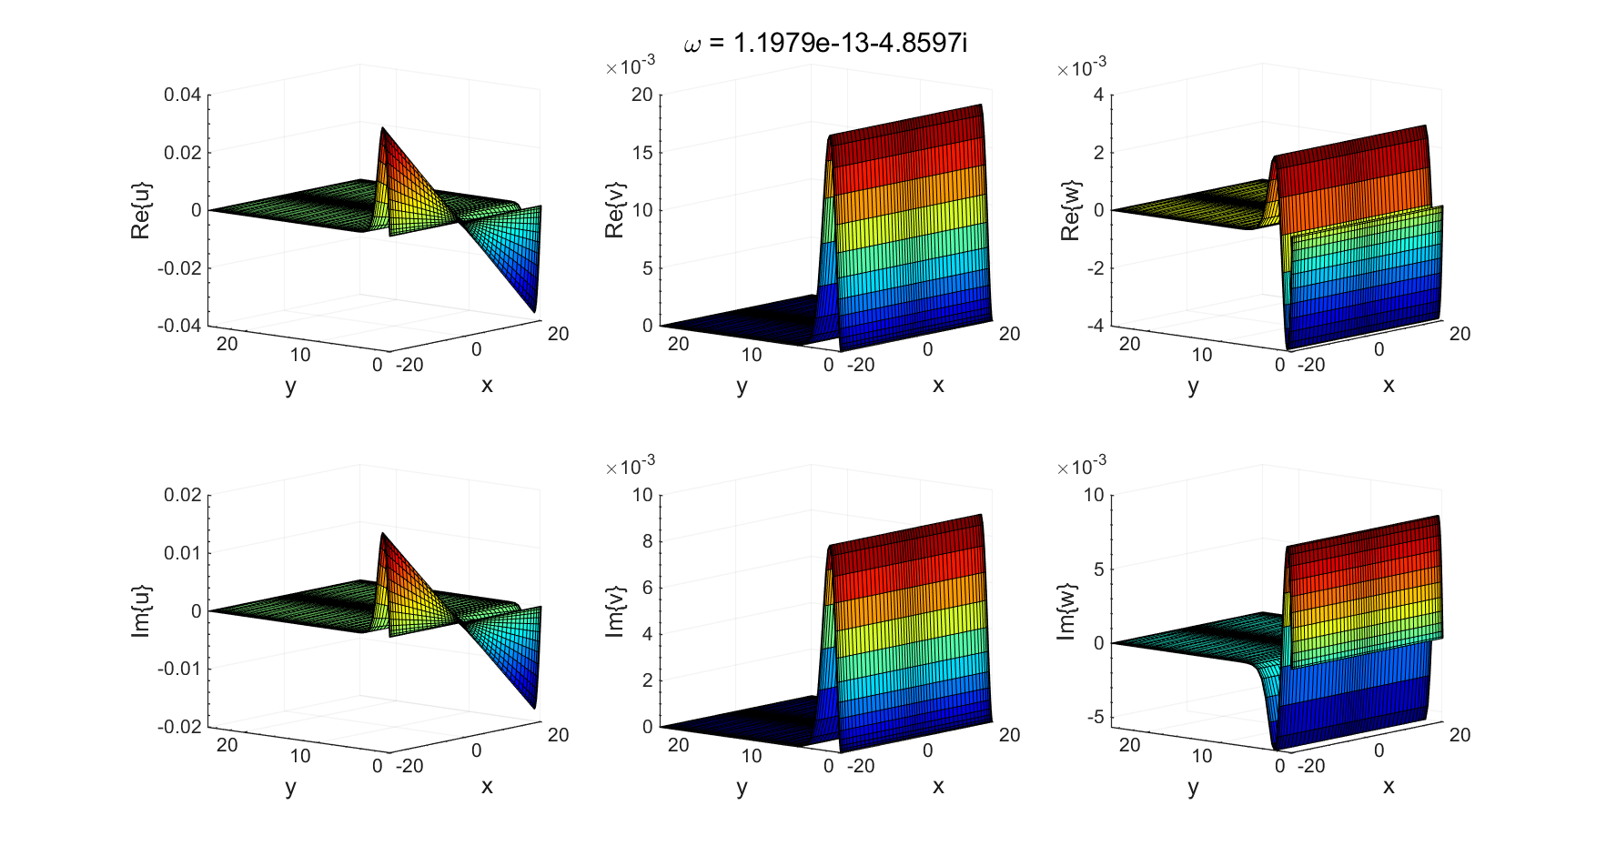

## Domain aspect ratio sensitivity

### X = 20



### X = 30

### X = 40

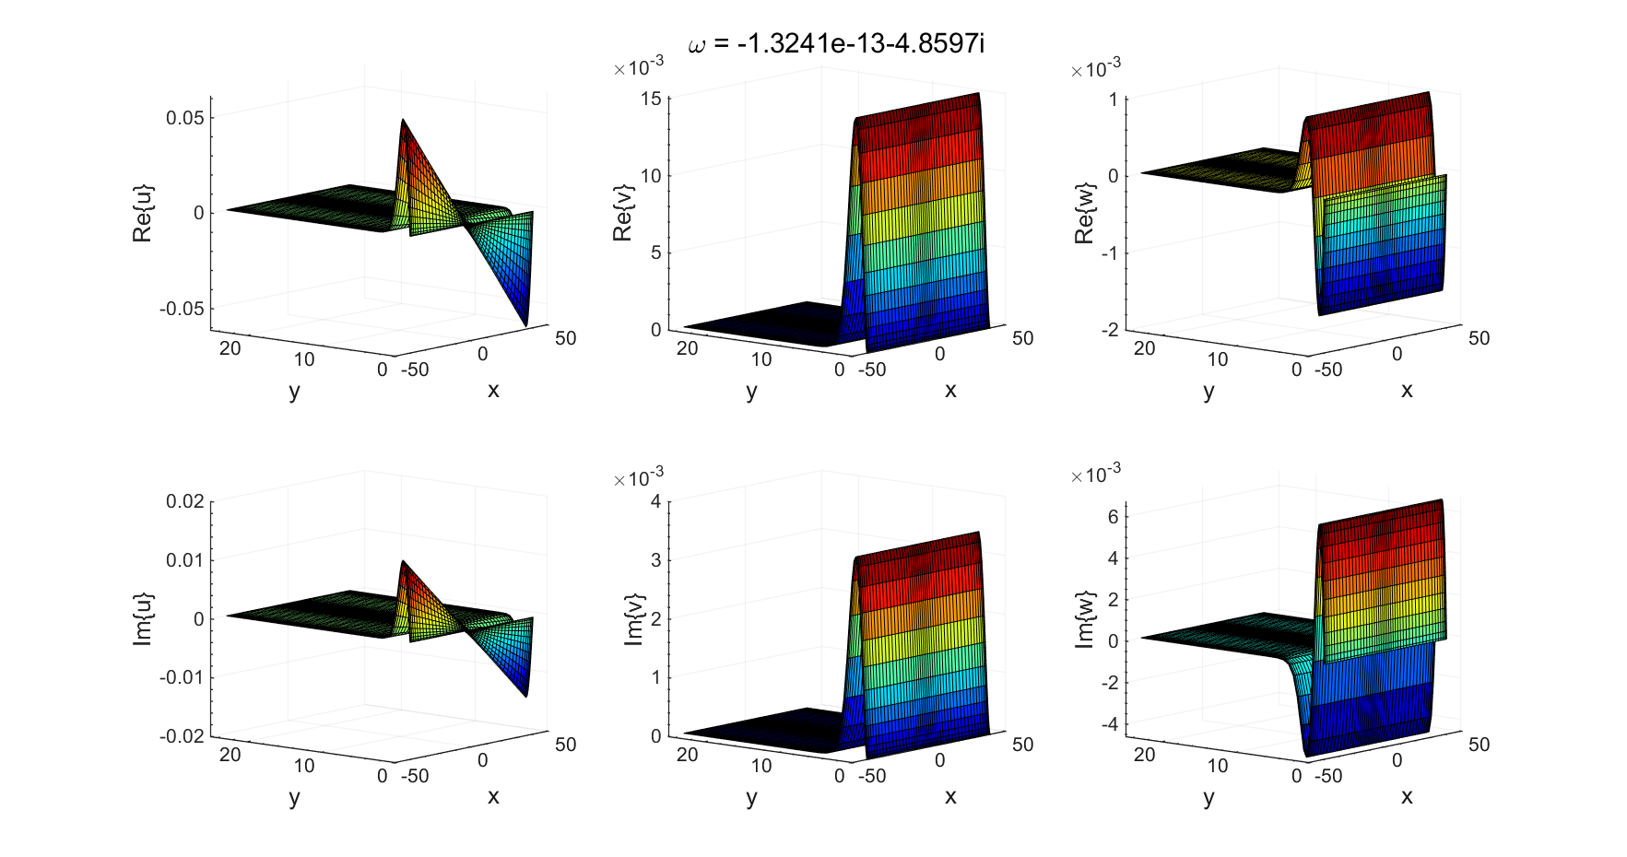

### X = 50

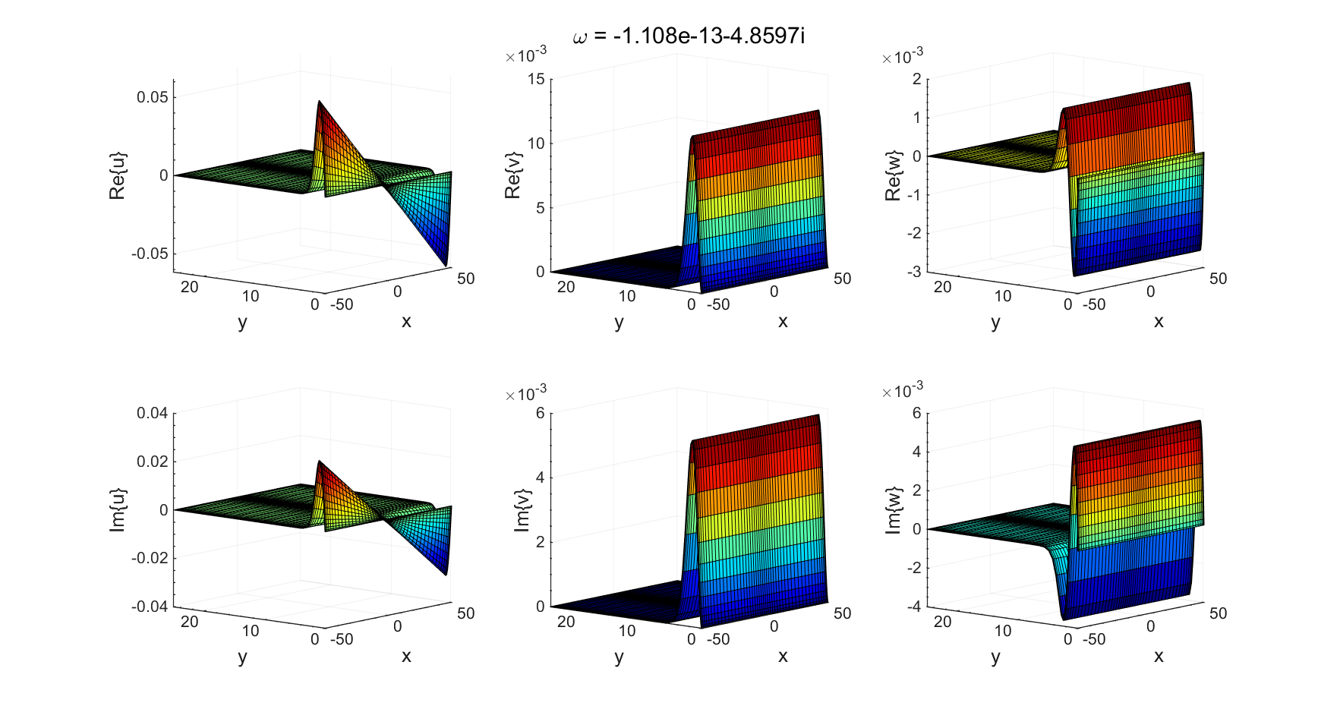

### X = 60

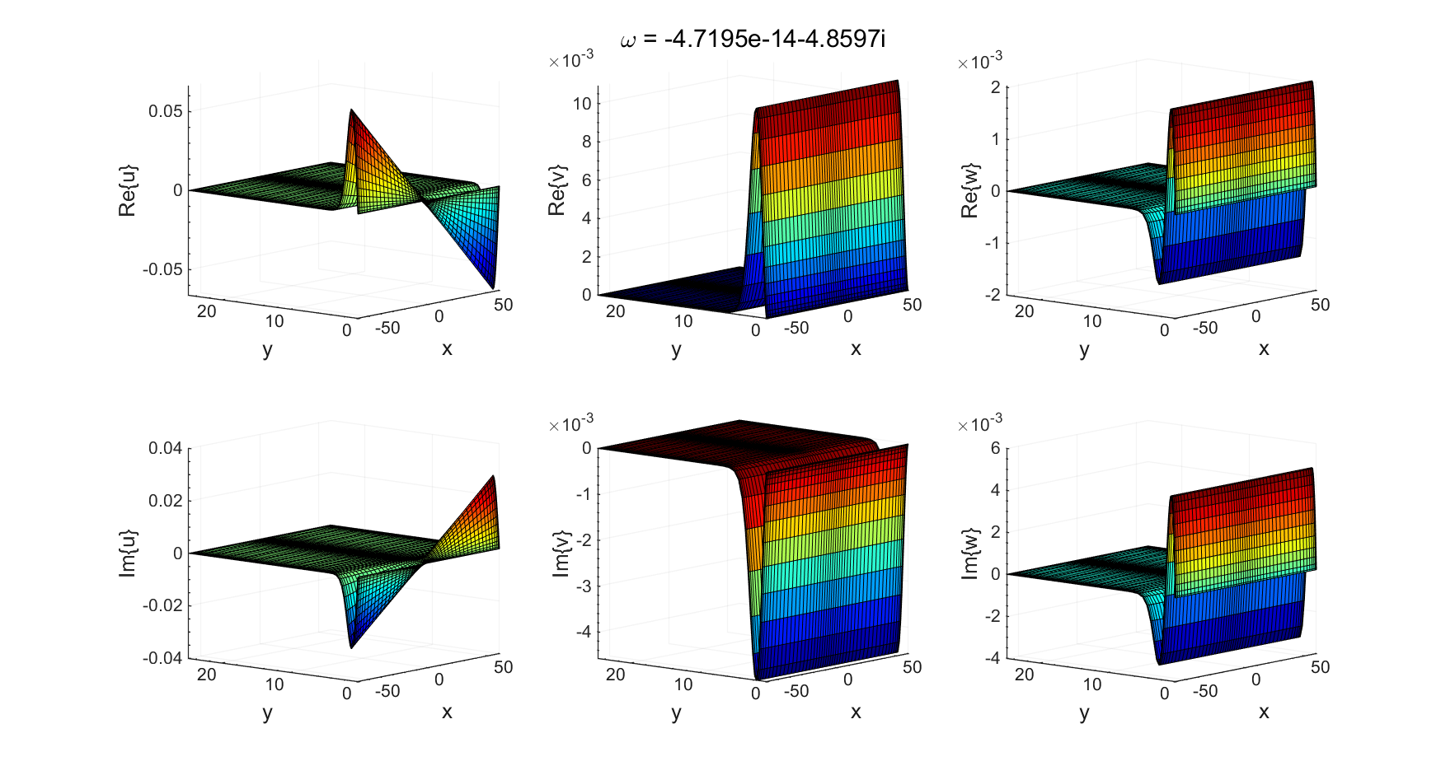

## Domain resolution sensitivity

### NX = 20, NY = 20

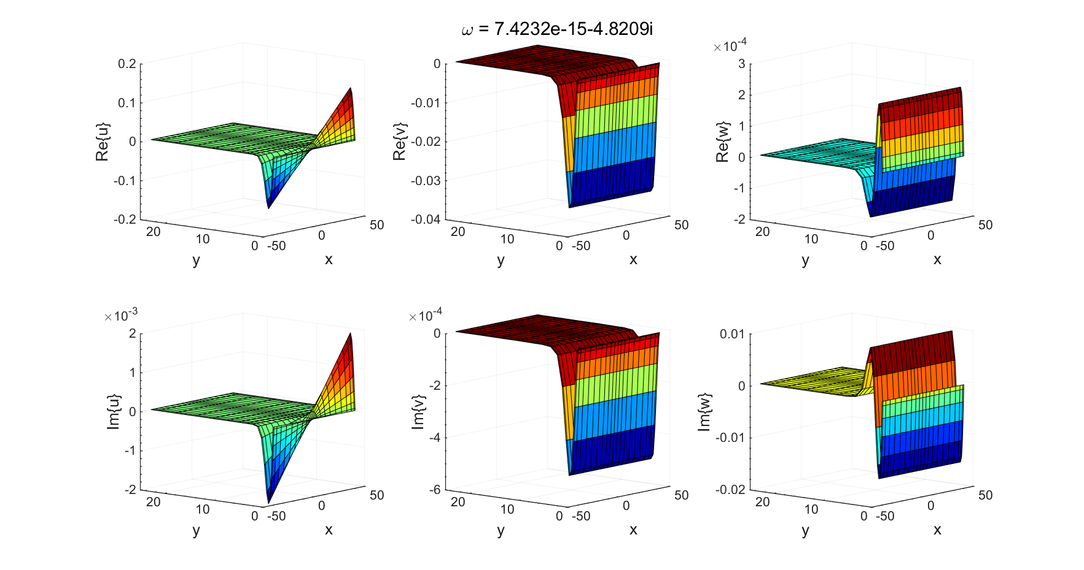

### Nx = 30, Ny = 30

### Nx = 40, Ny = 40

### Nx = 50, Ny = 50

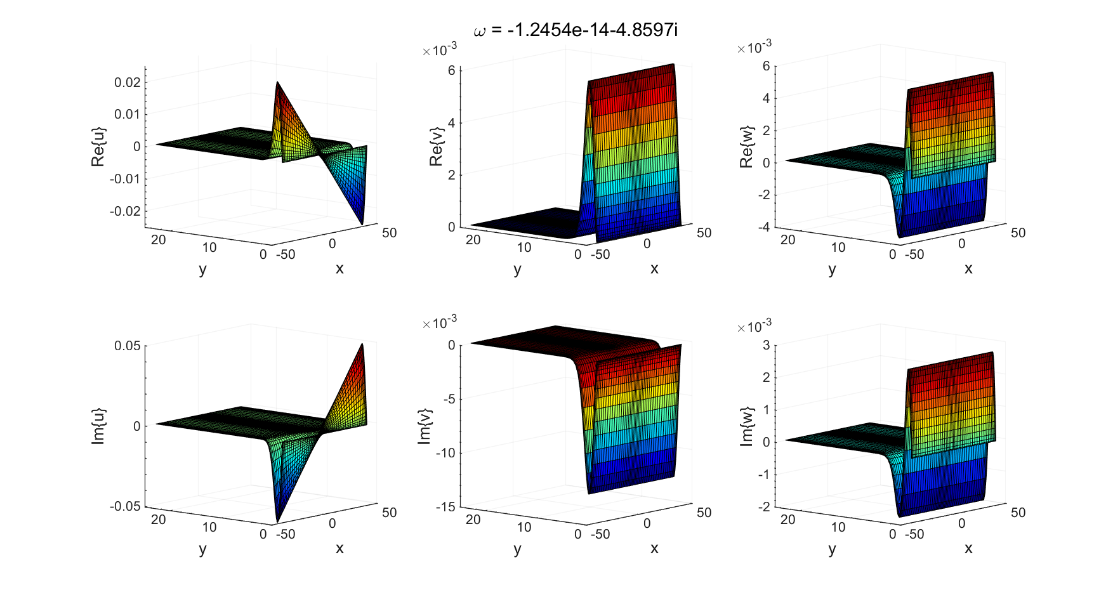

## Wall boundary conditions sensitivity

### Pressure compatibility conditions

### Linearized pressure Poisson equation



## Far-field boundary conditions sensitivity

### p = 0



### Linearized pressure Poisson equation